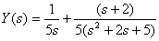

Y(t) = e^{-5t} + cos(5t

Rules

$\frac{1}{s+a}$ → e^{-at}

$\frac{s}{s^{2}+ω^{2}}$ → cos(ω.t)

