T-S DIAGRAM HOMEWORK NAME
(20 pts total)

The graph on page 2 comes from a field program I was involved with in the Eastern Pacific. Ocean probes descended into the ocean measuring both temperature and salinity. The left panel shows temperature versus depth while the right panel shows salinity versus depth. These readings were taken at a latitude of 8 ½ degrees North and 97 degrees West on September 13, 2001. By reading off the charts and using the T-S diagram on Page 3, fill in the following information (15 pts):

Depth (meters) | Temperature (degrees Celsius) | Salinity (parts per thousand) | Density (kg/m³)
20
40
60
80
100

From what you know about thermoclines and haloclines, give an approximate depth for the following (5 pts). Note: Don’t forget UNITS!!

Start of the thermocline _________________________

Start of the halocline ___________________________

Approximate depth of the mixed layer _____________

Extra Credit (2 pts): Is this arrangement of water stable or unstable? Explain why.

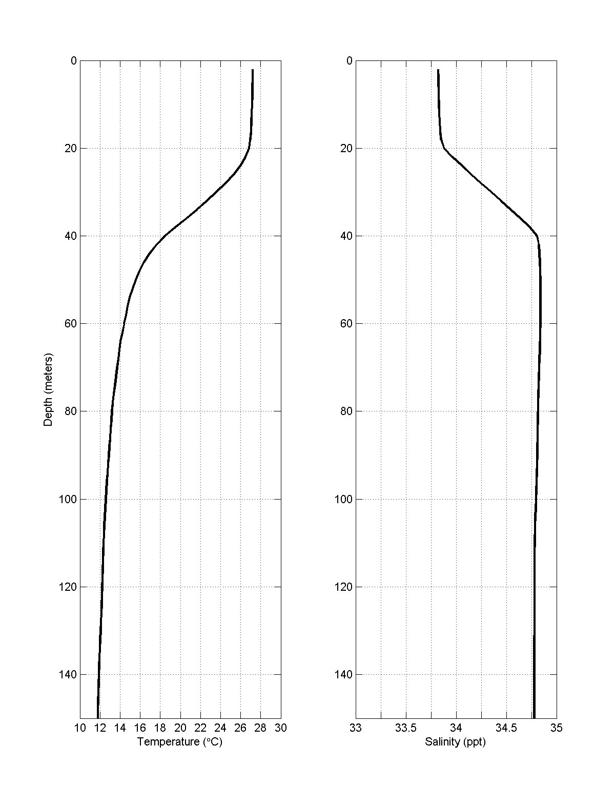
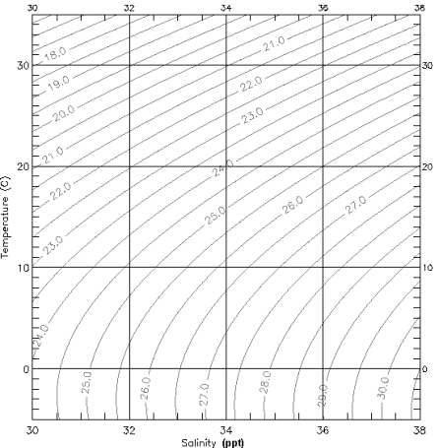
IMPORTANT: Notice that the values on the density curves or lines are incomplete. They should read 1.030 g/cm³ or 1.025g/cm³ or 1025 g/dm³ and so forth! See figure7.26. Hint a cubic meter of pure water has a mass of 1000kg!

