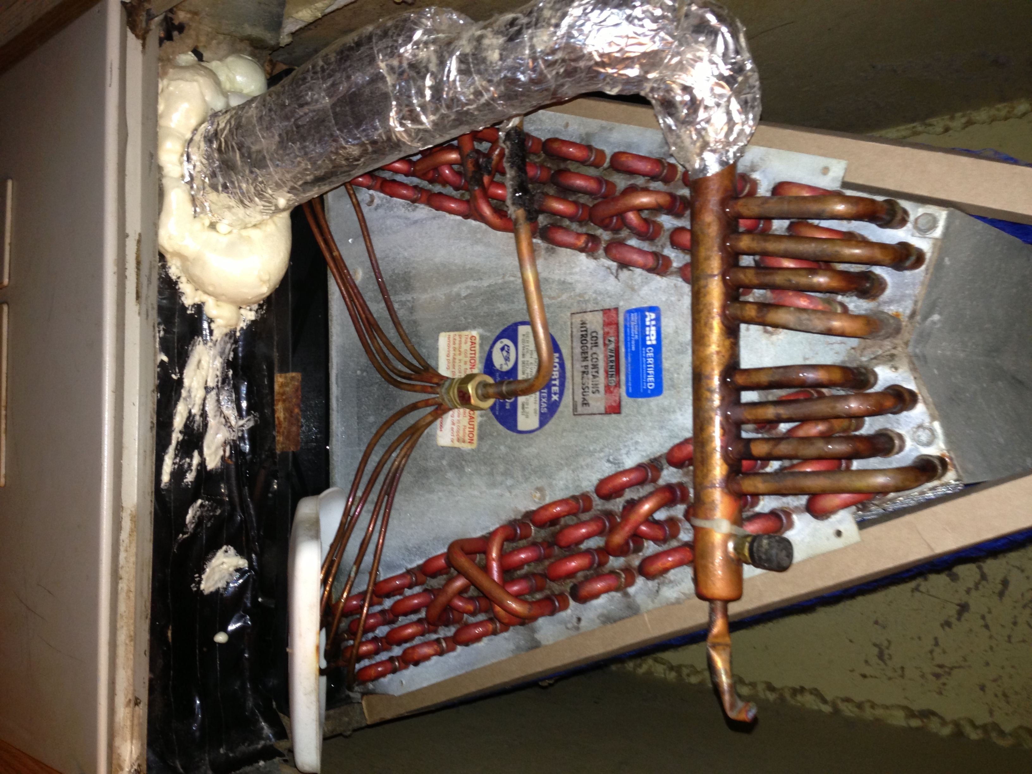

I had to put a plastic lid (white) under the copper lines to keep the water from dripping outside of the pan right after the new installation. And the plumbing corrected.

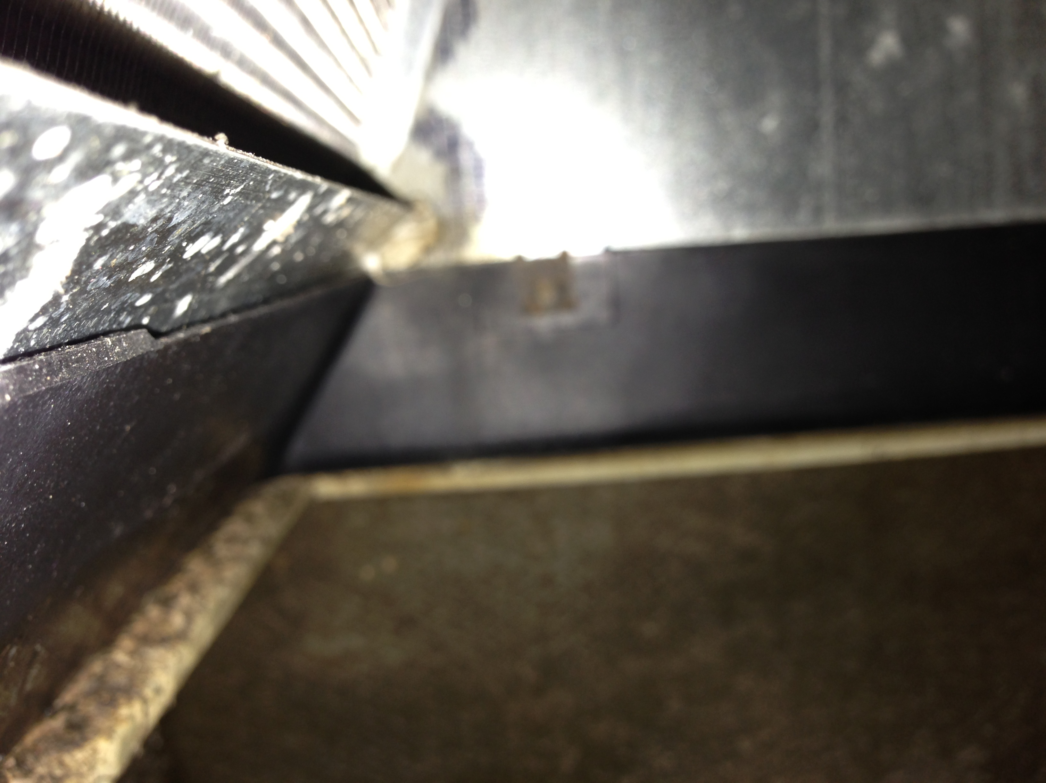

I put my phone inside this area and took a picture after the ac was off all night so my phone would not get wet. This is the area where it is dripping. Taken 2 days ago.

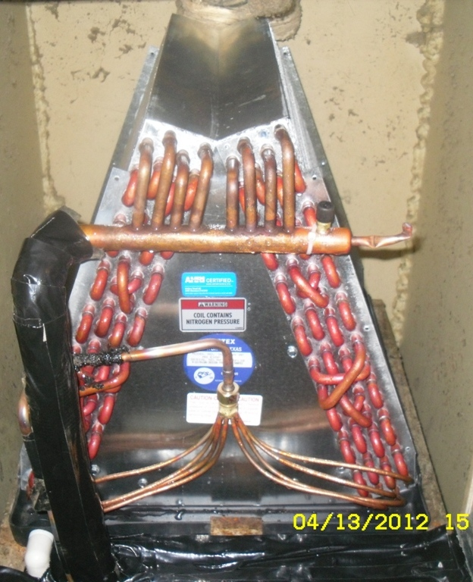
Right after this was installed.
Top circle, the cork tape is not an inch thick. The bottom 2 circles is where the copper lines hang over the black drain pan. Also they were suppose to put new foam insulation over the big copper line that has black tape over it. The red circles is where the condensation is dripping off the copper lines over the drain pan. This unit has only ran 20 mins. I had to put a plastic container on top of the black tape to catch the water.

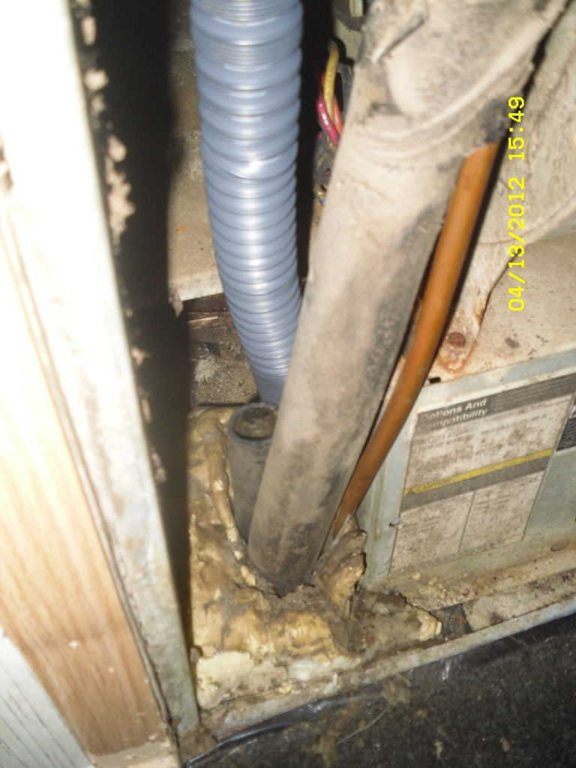

Right after the unit was installed the next morning. This is the drain line that was not hooked up, the flexi line would not fit inside the line.
The red circle is showing the drain line coming up from the floor.

This is the unit which was ordered from eBay from the HVAC Company.

The unit is this unit
http://www.ebay.com/itm/3-3-1-2-Ton-Mobile-Home-Coil-Replacement-MBC42CQA-MBC42CQD-MBH36DQD-/310382970641?_trksid=p4340.m185&_trkparms=algo%3DSIC.NPJS%26its%3DI%252BC%26itu%3DUA%26otn%3D5%26pmod%3D150297565516%26ps%3D63%26clkid%3D7772338624403267273

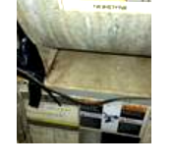
I have taped the wires until I can do something about the water leaking on them. I just took this picture.

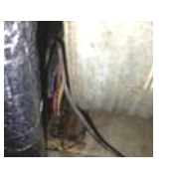
The wires getting wet before I put tape over them.

I have also researched and found out that a Without the p- trap installs, the air handler negative pressure will pull in the positive pressure air, this prevents condensate water from flowing. and also there was not gaskets put on the pan.

I don't know but I never had a p trap and I've lived here since the home was brand new since 1997 and the first issue was the outside Condenser which was replaced at $1485.00 on 4-4-06. It is a 3 ton Goodman unit.

